Contents

Top Tips 1

Excel Functions ( shift-F3 ) 2

Names 4

Vba 5

Immediate Window 6

UDFs User Defined Functions and LAMBDA 8

APIs 8

Events 8

Reading a File 9

Create a Button Macro 9

Add Ins 9

Tabs 10

More Tips 11

Lookup Example 12

Python Example 13

Extra Stuff 14

Pivot Table 14

Misc 19

# Top Tips

F9 calculate now : changed and dependent cells in all sheets, resetes dirtied cells

To easily see where a cell is referenced, click Formulas>Trace Dependents

F2+Enter calculate only the focused cell

Shift-F9 calculate sheet : (only) does not reset anything

Ctl-Alt-F9 calculate all sheets even if the cells that don’t need it

Workbooks by default are set to auto calculate, but functions like =rand() or =datetime() wont update every second, you need to hit F9

Ctl+’ (control backtick) expand all formulas

volatile cell/function calculates whenever any calculation occurs, now() and rand() are volatile

dirty cell a dependent cell that needs recalculating because a precedent cell has changed

get quick record count ? just click on cell column header ( excel shows the "cell count" )

or select any range of cells on the bottom will be count, avg, etc..

create a named range Formulas > Define Name or Name Manager ( or type in the name dropdown)

to find duplicates =UNIQUE(FILTER(colA, COUNTIF(colA,colA) >=2))

CTL or END and UP/DOWN/LEFT/RIGHT ARROW

positions you to the “most” top/bottom/left/right

END then Shift Right Arrow selects to right end of data

END then Shift Down Arrow selects to bottom of data

AGAIN : ctl (or END)-arrow moves you somewhere, end-shift-arrow select a range of cells

Range("B1").End(xlUp).Value is the same as END-DownArrow or CTL-DownArrow

CTL-SHIFT-HOME selects from cursor to the top left

CTL-SHIFT-END selects from cursor to the bottom right

to autofill across a data range, select and copy 1 value, then SHIFT, END and ARROW to select a range, then paste

select a range, print, settings>print selection to just print the selection

select a range, a little box appears you can make a chart or apply a function

select a range, click Data-->Remove Duplicates to see unique values

select a range, print, settings-->print selection to just print the selection

=worksheet1!$O$9 put the worksheet name and exclamation point

=ISNA(C1,1,0) if C1 is a #NA error the 1 else 0

the bottom grid shows few stats on all *selected* cells, right click to add other functions like min() and max()



#VALUE wrong data type for operand

#N/A incomplete formula

#NAME undefined NAME

#NULL 2 cells dont intersect

#REF reference is deleted

###### value is too long to fit

## Excel Functions ( shift-F3 )

=LN(67) 2.781 to the power of 4.2 = 67

=LOG(67,2.71828) 2.781 to the power of 4.2 = 67

=EXP(4.2047) 2.781 to the power of 4.2 = 67

=A2*((1+B2/D2)^(C2*D2)) compound int

D2 i # of periods per year and C2 is # of years

B2 is rate, have to translate annual to monthly rate

=A25*(1+B25/360)^E25 compound repo interest

A25 = cash B25=rate E25=days

=(A4)*EXP($M$3) continuous compounding, A4=principal, M3=rate

if calculating for 1 month, then divide M3/12

=TODAY()

=WORKDAY(I1,4,L1:L3) gives the next business date where 3rd parameter is a list of holidays

=WORKDAY(I1,4,holidays) same where “holidays” is a Named list

=DAYS360(C6,D6,FALSE) get days using 30/360

=INTRATE(DATE(2019,11,10),DATE(2049,11,10),E41,E40,1) returns yield given 2 dates, the investment, return

=DURATION("8/15/2019","8/15/2029",C2,D2,2,1) settlement, maturity, coupon, yield, frequency

=MDURATION("8/15/2019","8/15/2029",C3,D3,2,1)

=INTRATE(DATE(2019,11,10),DATE(2049,11,10),E41,E40,1) returns yield given 2 dates, the investment, return

=SIN(RADIANS(A4)) ( or COS/TAN ) you have to convert degrees to radians

=PMT(0.0145, 1,1000000,0, 0) interest payments, better to do it manually

To do a datediff on dates in A12 and A11 just do A12-A11

=B4^B2 or =POWER(B4,B2) B4 to the power of B2

=IF(RAND()<0.5,1,0) shows 1 50% of the time, keep clicking F9 to reseed

=IF(Sheet1!C18>25000000,"Over 25MM","") displays "Over 25MM” if C18 is over 25MM

=IF((J50+E50)=I50,"Y","N") print out N if column I does not equal the sum of columns E and J

=IF(L2=IF(O2="I",I2-F2,F2-I2),"Y","N")

=COUNTIF(B2:B72,">1") count the number of rows where column B is > 1

=SUMIF(A2:A72,">4",B2:B72) calculate the sum of column B values where column A > 4

=SUMIFS(C23:C32,J23:J32,">3",F23:F32,">100") sumifs for multiple criteria

=RANDBETWEEN(1,100) generates a random # between1 and 100

=VALUE(LEFT([@Review],1) [@Review] take field from column with the header "Review"

LEFT take the left (substing) 1st character

VALUE translate it to numeric

="Today is " & TEXT(TODAY(),"dddd") displays Today is Thursday

Ctl and ; gives current date ( as a text, use TODAY() if you want it to auto update )

Ctl-Shift and ; gives current time (or =NOW() to auto update)

=A1&B1 concatenates (or =A1 & " " & B1)

=CONCATANATE(A3," ",B3) ditto

=ROW(J4) returns the row# ( J4 would be 4 )

=ROWS($J$4:A31) # of rows J4:A31 would be 24

=COUNT(F2:F753) # of cells, only counts valid values (ignores headers or blanks)

=Large(Sales,3) returns the third largest value of the Sales range

=Sum(Large(Sales,{1,2,3}) returns the sum of the top 3 values in the Sales range

="Amount due: " & TEXT(A3,"$#,##0.00")& " USD"

=SUM(B2:B10,B18,B22:B25) pick and choose cells

to avoid a “#DIV/0 ! “ display use IFERROR(G3/G2,0) to display 0 instead

you can auto size a single cell, put your cursor between the column grid letters, it looks like 2 arrows, then double click !

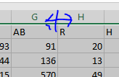

or select several columns, or select all, and do the same thing !

# Names

Technically ever cell has a name, like D9. The *Name DropDown* appears above A1

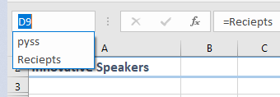

select a range of data, type a new name in the name drop down

or

select a range of data , right click, click Define Name

to see all your names, Formula>Name Manager

Names persist when you save the file.

A name may simply be a formula i.e. “=Reciepts-Expenses”

Names.Add Name:="TotalRuns", RefersTo:="=SUM(Mets!$D$2:$D$101)"

Note: if the name does not reference cells on the sheet, it wont appear in the drop down

*Tables* are similar but different. Tables are created manually by selecting data, and then Home>Format as Table

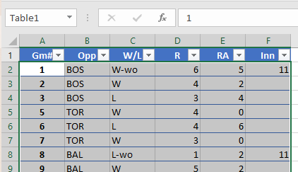

Table1 now appears in both the Name drop down as well as Name Manager

# Vba

CS used F# to create xlls

Excel DNA allows you to use C# or F# to create .xlls or .dlls

can install it through Visual Studio Manage Nuget Package

To the left, Project Manager up top. Properties on Bottom.

To the right, Code Window up top. Immediate and Watches on Bottom.

Code may be within a worksheet. Or “This Workbook”

Window>Tile might help to get an overview of code windows.

Object Browser (select VBA Project) .. note this is spreadsheet specific, so check which spreadsheet is highlighted

You can right click on the tab of any worksheet OR directly on the work sheet

Within the Project Manager, to see the code for that worksheet ( in the sheet window )

## Immediate Window

Debug.Print ActiveCell.Value ‘ to help debug, send output to the ***immediate window*** a.k.a. console

You can type commands directly into it, like ? VarType(objFSO) to get the data type

VarType() returns an enum that includes

vbEmpty 0 Empty (uninitialized)

vbNull 1 Null (no valid data)

vbInteger 2 Integer

vbDate 7 Date value

vbString 8 String

vbObject 9 Object

put your cursor on any function and click F1 to get help

grammar is object.method, and every single object becomes a collection by adding “s” to it

|  |  |  |
| --- | --- | --- |
| **Component** | **Grammar** | **Example** |
| object | noun | Application |
| collection | plural noun | Worksheets(2) |
| method | verb | Application.Calculate |
| parameter | adverb | Before:=Worksheets(2) |
| property | adjective | activecell.height=10 |

WS_Count = ActiveWorkbook.Worksheets.Count

Worksheets.Add ‘ just adds a worksheet

Set ws2 = Worksheets.Add() ‘ to return the object to a variable make it a function

auto_open runs automatically on open

Ix = 2

Do While Not IsEmpty(ActiveSheet.Rows(Ix).Cells(1))

Ix = Ix + 1

ActiveCell.FormulaR1C1 = "DOLVAR"

Selection.NumberFormat = "000.00000000"

Loop

Windows(FromFile).Activate

ActiveWindow.Close SaveChanges:=False

Kill PathandToFile

Range("A1:C3").Offset(1, 1) refers to range (B2:D4)

R1C1 is the legacy range protocal from the days of VisCalc and Lots 1-2-3. You may see it in recorded macro code

Here we define a formulat using both R1C1 vs. A1 methods

Range("D4").Formula = "=B3*10"

Range("D4").FormulaR1C1 = "=R3C2*10"

Rng.Offset(, -1).Resize(, 2).Interior.ColorIndex = 15 ‘ offset and resize together *expand* the range

To generically set the range…

lastrow = ActiveSheet.Range("A" & Rows.Count).End(xlUp).Row

With Range("B1:B" & lastrow) ‘ the “With range” infers commands in the loop (Ending with End With)

‘ delete row if column 1 is blanks

Sub DeleteBlankRows()

lastrow = Cells(Rows.Count, 1).End(xlUp).Row

Dim ent_row As Range

For i = 1 To lastrow ' 1 looks like l, this is ONE not an L

Set ent_row = Cells(i, 1).EntireRow

If Application.WorksheetFunction.CountA(ent_row) = 0 Then

ent_row.Delete

End If

Next i

End Sub

Debug.Print ActiveCell.Value ‘ to help debug, send output to the ***immediate window*** a.k.a. console

MsgBox ActiveCell.Value ‘ to send a pop

‘ error trapping

On Error GoTo 0

On Error Resume Next

Range.End properties : xlDown, xlUp, xlToRight, xlToLeft … these operate the same as End + arrow keys

Range("B1").End(xlDown).Value value in last row

Range("B1").End(xlUp).Value value in first row

Range.End does not imply last, it can be first or last, column or row

Range.Select does what you normally do interactively when you highlight cells , to wipe out the values in this range..

Set example = Range("B1:C3")

example.Select

Selection.ClearContents

Copy cells from here to there : Cells(i, 1).Resize(1, 8).Copy Destination:=Cells(NextRow, 1)

Application.Calculation = xlCalculationManual

# UDFs User Defined Functions and LAMBDA

Shift-F3 gives you access to all functins. One of the categories is User Defined…

Function IsEmailValid(strEmail As String) As Boolean ‘ returns a bool

Function LastSaved(FullPath As String) As Date ‘ returns a date

You “return” by setting the function name ( an implied variable ) with the value, i.e.

LastSaved = FileDateTime(FullPath)

You cant jump to a function via View Code but you can double click on it in object browser

LAMBDA is a hacky way to attach code to a name. This enables you to store code in a macro-free workbook

# APIs

APIs are a generic Windows functions stored in the dlls in C:\Windows\System32

You must declare the function in order to use it, i.e. to use the GetUserName function

Private Declare PtrSafe Function GetUserName Lib "advapi32.dll" _

Alias "GetUserNameA" (ByVal lpBuffer As String, nSize As Long) As LongPtr

# Events

3 common methods

control_event i.e. Private buttonName_Click()

workbook_event i.e. Workbook_BeforeClose

worksheet_event i.e. Worksheet_SelectionChange

Workbook_Open executes when a file is opened programatically or by a user

Auto_Open only executes when a user opens it

Worksheet_Calculate has some subtleies in regards to which F9 you hit

Others:

AppEvent_AfterCalculate

Chart_BeforeRightClick

# Reading a File

This is the OOP way….

Dim objTS 'define an object

Set objFSO = CreateObject("Scripting.FileSystemObject")

Set objTS = objFSO.OpenTextFile(path_file, ForReading, TristateUseDefault)

This is the way that mimics the manual “Open File” method..

Workbooks.OpenText Filename:=path_file DataType=:xlDelimited

Note : xlDelimited=1 and xlFixedWidth=2 is the xlTextParsingType enum. VBA has tons of enums.

# Create a Button Macro

From Developer tab, click Insert and button is the first choice of many controls. Then add your macro.

You can create a shortcut of Control-Whatever from Developer tab, Macros>Options

You can also add it to the “Quick Access Toolbar” by right clicking on it and select “Customize the Ribbon”

# Add Ins

Managed via File>Options>AddIns OR the Developer tab has buttons for AddIns, COM AddIns, Excel AddIns

.xll or .dll files created by C or .Net (these are the same thing) You cant decompile C but maybe .Net

.xla a for addin, legacy extension

.xlam a for addin. Created by vba, macro enabled, zip compressed

.xlsm is an .xlsx file with embedded macros

.xlsb is an .xlsx file stored in binary format, it performs better but takes up more space

.xlsx stored in xml format

Microsoft addins are here C:\Program Files\Microsoft Office\root\Office16\Library\(Solver or Analysis)

C:\Users\arono\AppData\Roaming\Microsoft\AddIns contains MY created add in temp files

C:\Users\arono\AppData\Roaming\Microsoft\Excel contains auto-recover files

C:\Program Files\Microsoft Office\root\Office16\Library\EUROTOOL.XLAM

Some add ins seem to only exist on the intranet even if you “Add” them

My FRED addin has stuff on www.s3.amazonaws.com

The “Automation…” button leads you to a lot of dlls called “Automation” but they can be anything.

Most of them are in C:\Windows\System32 but some are by Adobe or other vendors.

to be accessible to excel, ***functions*** must be 1) exported by the xll and 2) registered w/excel

# Tabs

**Home**

Format

To hide/unhide rows Home>Format>Hide and Unhide ( or Ctl-0 Ctl-9 etc.. )

AutoSum

Has average, sum, max, min, hundreds of functions !

Conditional Formatting

select a range, to put #s over 1000 in bold

**Insert**

Pivot Table, Shapes, Charts, Text Box, Equation

Page Layout

Margin, Orientation

Unclick “View Headings” to remove the cell/row identifiers

**Formulas**

**Show Formulas** control-backtick shows all formulas in the spreadsheet

**Trace Precedents/Dependents** to see where a cell is referenced

Name Manager

Calculate Entire Workbook F9

Calculate Active Sheet only Shift-F9

Note : under calculation options, the default is automatically calculate whenever a precedent is changed

**Data**

Remove Duplicates, What-If Analysis

**Subtotals/Group/Ungroup** is an “in-place” pivot table

**Data Analysis** (is an add in) statistics

**Solver** (an add in) solves equations

**Consolidate** to combine worksheets

**View**

**New Window** opens 1 spreadsheet in multiple windows

**Split** splits 1 sheet into 2 scroll

**Arrange** tile all sheets

**Developer**

**COM Add-ins** automate Excel in response to a click of a CommandBar button, a form or dialog box

Insert>Form and Active-X Controls

**Add-Ins** to choose from many add-ins (Financial subset) believe they are kept in the cloud

**Excel Add-Ins** are on your local machine

# More Tips

to copy a worksheet, with data, click CTL, and drag the worksheet tab to the right

to make same changes on all worksheets, ( like column headers or totals ) click SHIFT, and select all worksheet tabs, make your changes

SUMIFS (IFS means multiple IF statements),… sum up column 3, where col 1 =Monday and col 2 = NorthEast

=SUMIFS(Last24Hours!C4:C19,Last24Hours!B4:B19,"=NorthEast",Last24Hours!A4:A19,"=Monday")

contrast this to IF,which is condition, true result, false result =IF(F3=1,"True","False")

drag and move any column, row, or set of fields, when your cursor becomes “4 arrows” ( which I cant snippet ) but it looks like

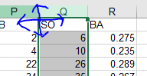

easy way to “jump” to the next blank cell…”Find and Select” and GoTo Special

this actually will select all blank cells at same time, which in theory you could right click and delete them all

if you paste some data that didn’t automatically parse into columns, try Data>Text To Columns

to highlight positions over 1MM, use Home>Conditional Formatting

## Lookup Example

INDEX and MATCH are suggested for complex keys

=INDEX{E5:E11,MATCH(1,(H5=B5:B11) * (H6=C5:C11) * (H7=D5:D11), 0))}

E5:E11 contains the values you are looking for

H5,H6,H7 contains the key you are starting from

Columns B,C,D contain the key you are trying to match

vlookup (Q3,$H$3:$N3001,3,FALSE)

Q3 contains the value you are looking for

H3 is the column to do the lookup on, must be SORTED, fix this with dollar signs

H3-N3001 is the range to consider

5 is 5 columns over from H, the volume to show

use FALSE, for exact match, TRUE is some fuzzy match

vlookup (K2,$A$2;$G29,1,FALSE) -- 1 just returns the lookup value

HLOOKUP exists to do the same thing column-wise

=VLOOKUP(F2,TEAMS,2,FALSE).

parameters are 1) Lookup Value, 2) Table Array, 3) Column, 4) Range Lookup

In a spreadsheet with 2 worksheets, called trades and bonds, where bonds contains just cusip and short name,

VLOOKUP AND HLOOKUP have some restrictions, you can only return a value to the right of your key, you have to sort your keys, you have to count the number of columns from key to value

if your worksheet contains a space, put it in single quotes.

=VLOOKUP(C3,'Pitcher Pivot'!$A$3:$C$19,2,FALSE)

XLOOKUP looks for a value in multiple columns

# Python Example

writer = pd.ExcelWriter(file, engine='xlsxwriter')

season_avgs.to_excel(writer, sheet_name='season_avgs')

ball_careers.to_excel(writer, sheet_name='careers')

workbook = writer.book # xlsxwriter.workbook.Workbook

worksheet = writer.sheets['careers']

green_format = workbook.add_format({'bg_color': '#C6EFCE', 'font_color': '#006100'})

bold = workbook.add_format({'bold': True})

worksheet.set_column('B:B', None, green_format)

worksheet.set_column('C1:C2', None, bold)

writer.save()

# Ammendum

To recompile your code changes: Debug>Compile VBA Project

“Modules” export as .bas and may be considered scripts

All others…ThisWorkbook, each sheet and ClassModules export as .cls and may be considered COM objects

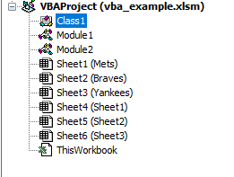

Add In Manager

|  |  |
| --- | --- |
| **Available Add-Ins** | Lists available add-ins. |
| **Load Behavior** | Displays the load behavior for the selected add-in. |
| **Description** | Displays a description of what the add-in does. |
| **Load Behavior** | **Loaded/Unloaded** check box: Loads or unloads the selected add-in. **Load On Startup** check box: Loads the selected add-in on startup of the development environment. **Command Line** check box: Loads the selected add-in when the development environment is started from the command prompt or from a script. |

F3 = Paste Name dialog box. Same as Formulas>Use In Formual>Paste Names and similar to Name Manager

F5 = Go To (some name)

Workbook_Open vs Auto_Open

workbook_open runs first and auto_open next when you open a book manually:  
BOTH will run UNLESS you keep SHIFT key pressed.

When you open a book with vba: the auto_open WILL NOT run UNLESS you add the line (after open)  
ActiveWorkbook.RunAutoMacros xlAutoOpen

the workbook event code WILL run UNLESS you add (before open)  
Application.EnableEvents = FALSE

Trust Center File> Options>Trust Center allows you to control how add ins load or whether macros can run

Application.EnableEvents = False turns off event firing

# Extra Stuff

Possibly Useful for formulas : Options:Advanced:EditingOptions

to get rid of that annoying green corner tools--->options---> de-select enable background error checking

if you see an @ before a function, it tells excel to combine multiple values to 1 cell

its possible excel did this automatically to a function that only returns 1 value

@func_value("n",$B$13,$B$164)

{} may be a legacy array notatin

# Pivot Table

Given a spreadsheet that has cpty, days ( 1 thru 5), cash, interest

To sum up by cpty/days…

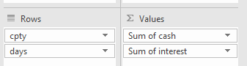

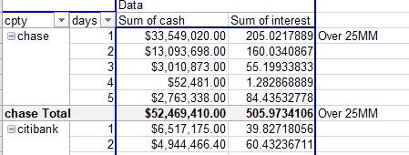

charts

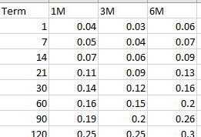

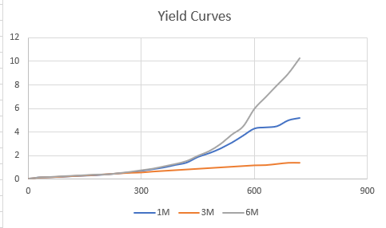

1) Select all 4 rows including Term

2) Insert : Scatter Plot WITH smooth lines

3) Right click on it : Click Format Plot Options

4) Click drop down for Axis Options

Select Horizontal Values

Click on Bar Char

Adjust Bounds and Units

if you just select one line… insert chart..lines…

you get a nice chart where x values are the row numbers

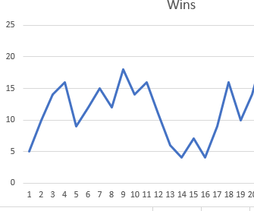

if you select 2 columns and you wish them to be x and y values, BUT they don’t form a line …

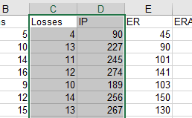

A clustered bar chart can be used to show the correlation between loses and innings pitched

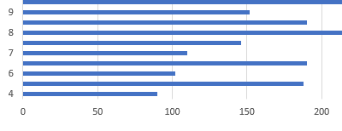

Right Click

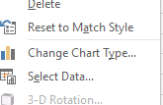

Select Data to review or modify the data inputs

Change Chart Type to change chart type

Add Ins

File>Options>Add Ins to add DataAnalysis for example ( which is a statistics tool ), at the bottom, select “Excel Add-Ins” which is the object type of DataAnalysis, then from that pop up select “Data Analysis” and click OK

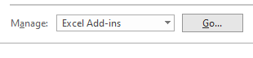

the Data tab will then have “Analysis” on the right.

Moving Average will allow you to define an interval, i.e. an interval of 6 on row 10 will be =AVERAGE(I5:I10). Click chart to display a char

standard error will be =SQRT(SUMXMY2(I7:I12,U7:U12)/6) ( similar to STDEV except with out the squaring and the mean )

SUMXMY2 Returns the sum of squares of differences of corresponding values in two arrays

Formula Auditing

To easily see where a cell is referenced, click Formulas>Trace Dependents

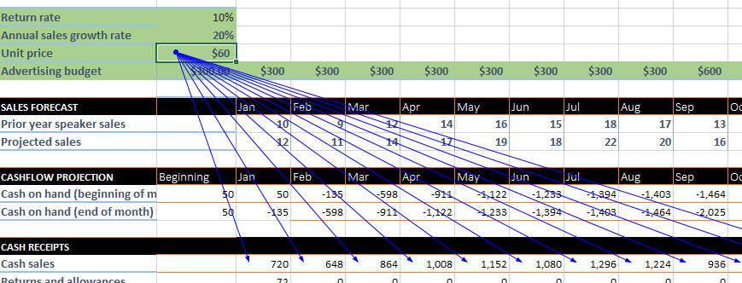

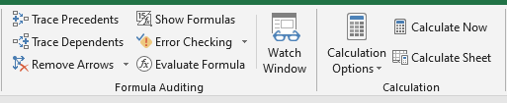

Evaluate Formula can help you debug a formula,

=M17*(1+$B$12+((M14/25)-2.75)/100) is projected sales

M17 = Prior Year Sales 19

1+$B$12 = Growth Rate 1.2

((M14/25)-2.75)/100 = Advertising Factor .3725 ( Advertising is $500 )

Data>Data Analysis

files, options, add-ins, manage, go, analysis tool pack and solver add-in

has Anova ( Analysis of Variance ), Moving Average, Correlation, Covariance, Random Number Generator and other Statistics functions

The excel Solver add-in allows you to find what parameters will result in your desired outcome

Budget Example

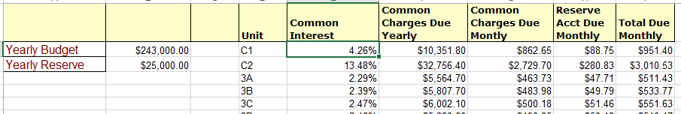

|  |  |
| --- | --- |
| Common Charges Due Yearly | =$B$2*E2 |
| Common Charges Due Monthly | =F2/12 |
| Reserve Account Due Monthly | =($B$3*E2)/12 |

Excel Arrays

Ctrl, Shift, and Enter is the hidden way to create an excel. Excel creates the brackets.

so if you see {=B12:B16*C12:C16} in column D12, then D12 holds B12*C12 and D13 holds B13*C13, etc..

it is exactly the same as typing =B12*C12 in D12, and dragging it down

however 2 advantages of the array {=B12:B16*C12:C16}

1) you can refer to it an other formulas or conditions

2) it may be more readable, it tells you right off the complete data set

# Misc

custom format $#,##0 " before bonus" translates to $255,000 before bonus

.xltx template files

+= if you see += in a formula, it’s the same as =

<http://www.contextures.com/tiptech.html>

<http://www.cpearson.com/Excel/Topic.aspx>

[www.jkp-ads.com](http://www.jkp-ads.com)

[www.MicrosoftPressStore.com/ExcelVBAMacros365/downloads](http://www.MicrosoftPressStore.com/ExcelVBAMacros365/downloads)